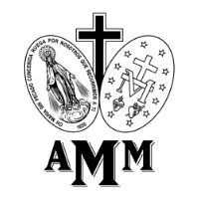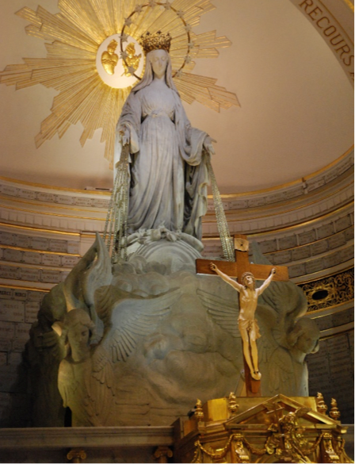

The Miraculous Medal Association

The Miraculous Medal Association is a living and perpetual memorial of the apparitions of the Immaculate Virgin Mary in 1830. In these apparitions the Virgin presented a model of the medal that, when copied, spread rapidly in many countries. It was the people who called this medal “miraculous” and they did so because of the innumerable blessings that God bestowed on them through this medal.

The Association came into existence in order to make known the Virgin of the Miraculous Medal and to transmit the message of the medal, viewing it as a catechetical lesson on the history of salvation offered by the Virgin Mary to those whose heart is open to her message.

Sign up now

**internationalmma.org**

The Miraculous Medal Association

Here is what the Miraculous Medal prayer group is about:

1. It is a prayer group that prays to Mary, the Blessed Mother by saying her novena. And by doing this, prays to God.
2. It thanks Mary for her great love to them as our Mother, and of course, thanks her for her great sacrifice in being the Mother of God, Jesus Christ our Lord.
3. The prayer group dedicates itself to helping bring Jesus Christ and devotion to Mary into the world.
4. It shares with each other during the meeting, the favors that it prayed for and has now received through Mary’s intercession.
5. They wear the Miraculous Medal and tell others how it came from Mary herself.
6. It asks Mary to help the members in their faith and in their own lives.
7. It asks Mary to help others in their lives.
8. Most importantly, it asks Mary to help people make a good confession and return to the Church.
9. By bringing people to pray in a group, it helps them get to know each other, be friendly with each other and pray together or share their faith.

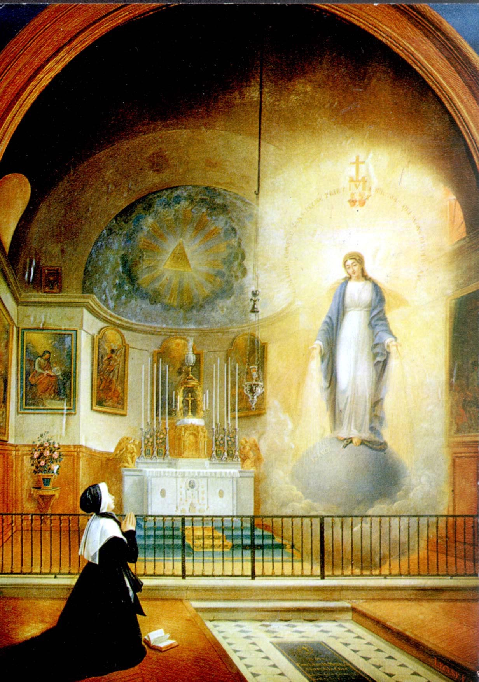

**Leader:** In the name of the Father, and of the Son, and of the Holy Spirit.

**People:** Amen.

**Leader:** Come, O Holy Spirit, fill the hearts of Your faithful, and kindle in them the fire of Your love. Send forth Your Spirit, and they shall be created.

**People:** And You shall renew the face of the earth.

**Leader:** Let us pray. Oh God, who did instruct the hearts of the faithful by the light of the Holy Spirit, grant us in the same Spirit to be truly wise and ever to rejoice in His consolation, through Jesus Christ, Our Lord.

**People:** Amen.

**Leader:** O Mary, conceived without sin.

**People:** Pray for us who have recourse to you (repeat 3 times)

**Leader and People:** O Lord, Jesus Christ, who have vouchsafed to glorify by numberless miracles the Blessed Virgin Mary, immaculate from the first moment of her conception, grant that all who devoutly implore her protection on earth, may eternally enjoy Your presence in heaven, who, with the Father and Holy Spirit, live and reign, God forever and ever. Amen.

O Lord, Jesus Christ, who for the accomplishment of Your greatest works, have chosen the weak things of the world, that no flesh may glory in Your sight; and who for a better and more widely diffused belief in the Immaculate Conception of Your Mother, have wished that the Miraculous Medal be manifested to Saint Catherine Labouré, grant we beseech You, that filled with like humility, we may glorify this mystery by word and work. Amen.

Memorare

Remember, O most compassionate Virgin Mary, that never was it known that anyone who fled to your protection, implored your assistance, or sought your intercession, was left unaided. Inspired with this confidence, we fly unto you, O Virgin of Virgins, our Mother; to you we come; before you we kneel, sinful and sorrowful. O Mother of the Word Incarnate, despise not our petitions, but, in your clemency, hear and answer them. Amen.

Novena Prayer

O Immaculate Virgin Mary, Mother of Our Lord Jesus and our Mother, penetrated with the most lively confidence in your all-powerful and never-failing intercession, manifested so often through the Miraculous Medal, we your loving and trustful children implore you to obtain for us the graces and favors we ask during this Novena, if they be beneficial to our immortal souls, and the souls for whom we pray.

(Here privately form your petitions.)

You know, O Mary, how often our souls have been the sanctuaries of your Son who hates iniquity. Obtain for us, then, a deep hatred of sin and that purity of heart which will attach us to God alone, so that our every thought, word and deed may tend to His greater glory. Obtain for us also a spirit of prayer and self-denial that we may recover by penance what we have lost by sin and at length attain to that blessed abode where you are the Queen of angels and of men. Amen.

An Act of Consecration to Our Lady of the Miraculous Medal

O Virgin Mother of God, Mary Immaculate, we dedicate and consecrate ourselves to you under the title of Our Lady of the Miraculous Medal. May this Medal be for each one of us a sure sign of your affection for us and a constant reminder of our duties toward you. Ever while wearing it, may we be blessed by your loving protection and preserved in the grace of your Son. O most powerful Virgin, Mother of our Savior, keep us close to you every moment of our lives. Obtain for us, your children, the grace of a happy death; so that, in union with you, we may enjoy the bliss of heaven forever. Amen.

Leader: O Mary, conceived without sin.

People: Pray for us who have recourse to you. (Repeat 3 times)